**The Arduino: Revolutionising the Scientific Method at a Low Cost**

* *Arnav Khetan, Krish Gangaraju, Sana Mohammed, Sreshta Pothula, Ved Srivathsa and Vedant Sagar*

Imagine having to spend hundreds of dollars and dozens of hours to set up a simple physics experiment. What if we told you we found a way to measure the speed of sound and light, for under $35 in just a couple of minutes using basic IoT. Ole Roemer took months calculating time intervals between eclipses only to be more than 75 million meters per second off, whereas we, a couple of students, were able to get a much closer value.

Don’t believe us? This is how we did it:

Schools generally use professionally made kits that cost upwards of $250 which we reduced by around 85%.

To measure the speed of sound and light, we use one of the most basic formulae in physics, Speed = Distance/Time. The challenge is in finding a reliable light or sound emitting source which is synchronised with clock measurements.

By emitting a sound/light wave from a sensor, and determining the time taken to receive the reflected wave from an object that has been placed at a predetermined distance away from the sensor, we can easily calculate the speed of these waves.

Our low-cost approach is to use integrated techniques of combining software (programming language C) and hardware (Arduino microcontroller, Ultrasonic sensor, Laser Ranging sensor, jumper cables, and breadboard).

First things first, measuring the speed of sound. The ultrasonic sensor was the key to doing this. It works as follows: -

(i) From the transmitter of the sensor, eight 40kHz ultrasonic signals travel towards an object

(ii) The signals are reflected from the object, and once the receiver of the sensor receives this signal, the formula finally comes into play

(iii) The time between transmission and receival of the signal is measured, and with the fixed distance, the speed is calculated (Speed = [2*Distance] / Time)

Like any experiment, we took several distances to ensure that our values were accurate.

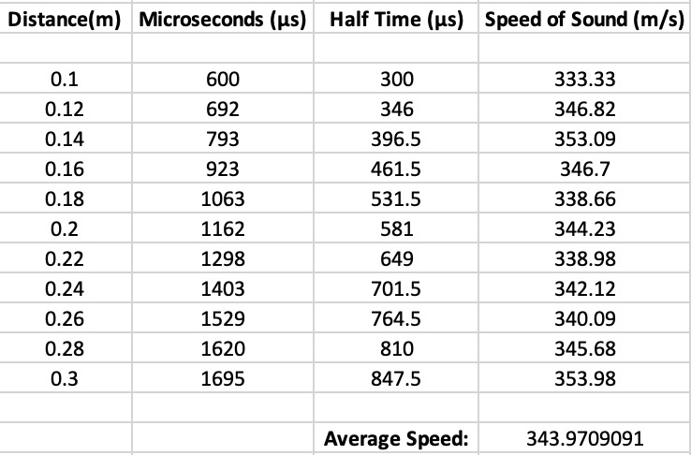 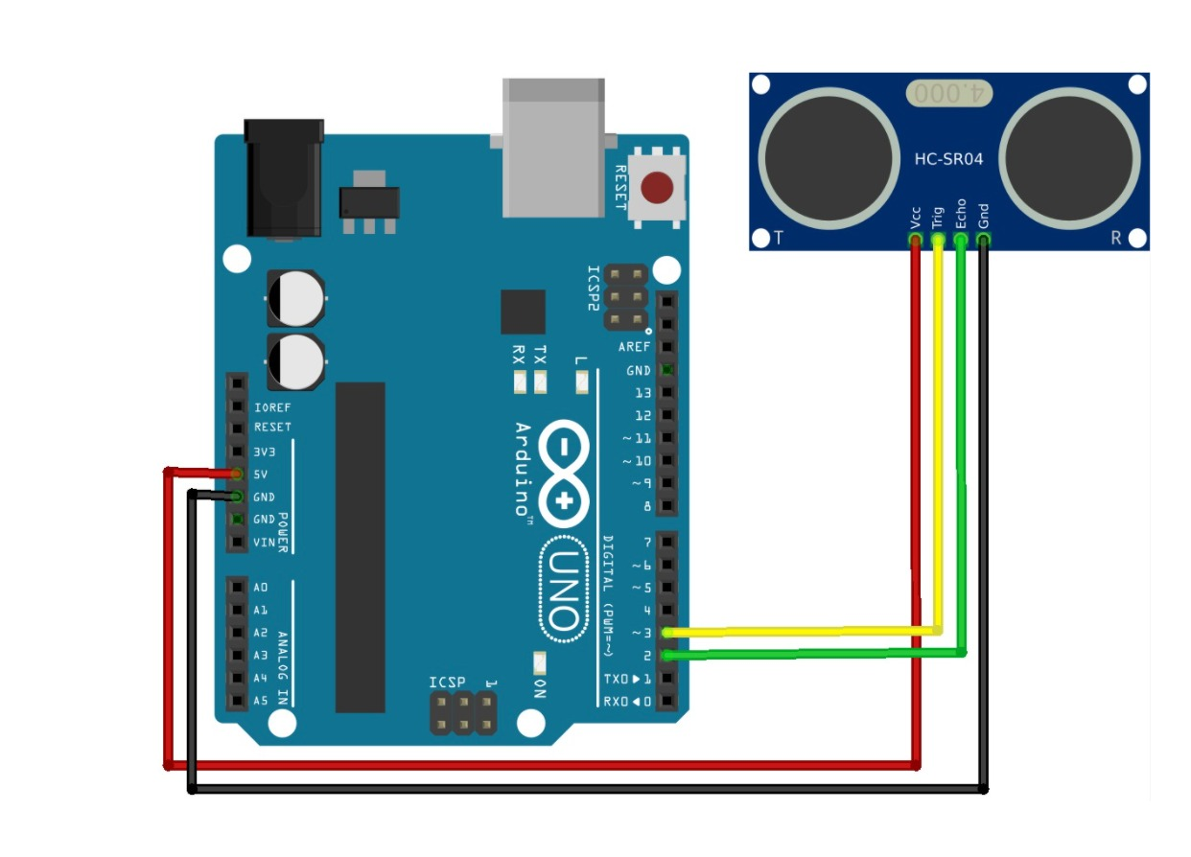

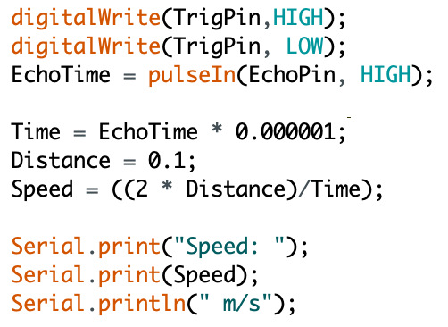 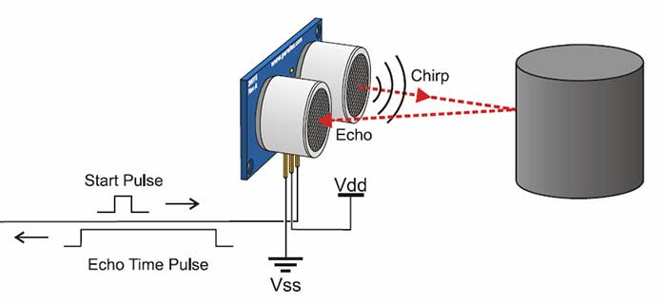

*The average calculated speed of sound with this experiment was 344 m/s*

Moving on to the speed of light. The working principle of the sensor used here (laser range sensor), is identical to the ultrasonic sensor with the exception that infrared light is used as the source. The experiment was carried out in the same manner with varying distances from 2 cm to 25 cm and by applying the same formula as above (Speed = [2*Distance] / Time) we were left with an absolute percentage error of only **3.73%**

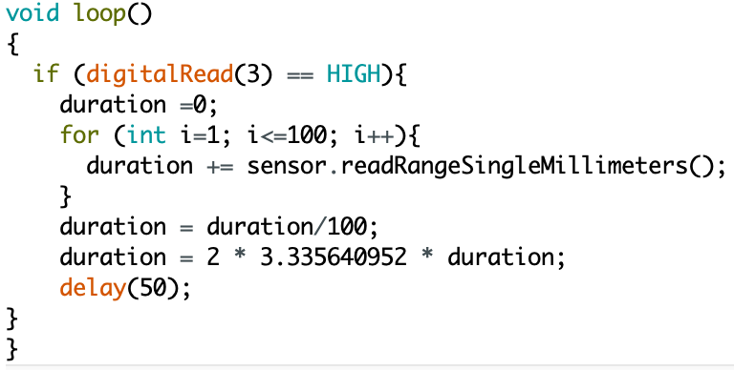

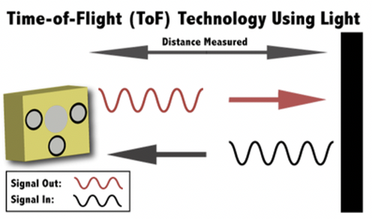

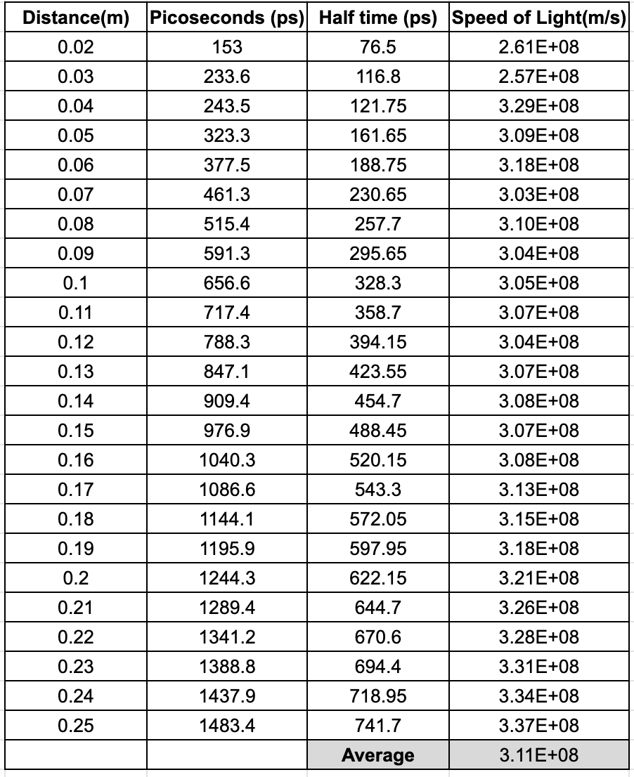

*The average calculated speed of light with this experiment was 3.11 x 10^8 m/s*

After all is said and done the measurements from the experiments were extremely close to the theoretical values, which goes to show that as technology progresses, it is important to look at IoT as an alternative method to conduct similar scientific experiments.

Here are the components required for these experiments and their prices

